Steps to change Email Logo

- logon into share application and navigate to Repository>Data Dictionary>Email Templates

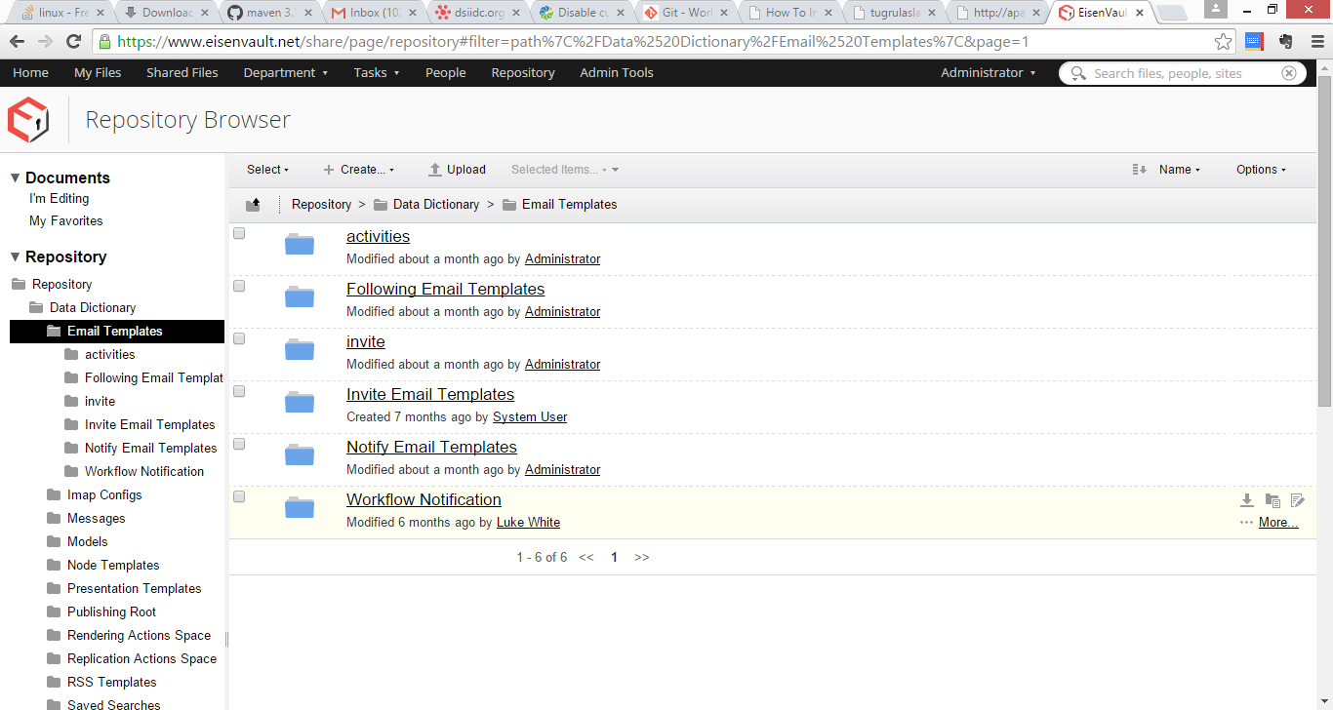

- To change the site invitaion email logo navigate to invite folder and edit the files invite-email.html.ftl and new-user-email.html.ftl as (we just have to remove the img logo entries from these files) shown above.

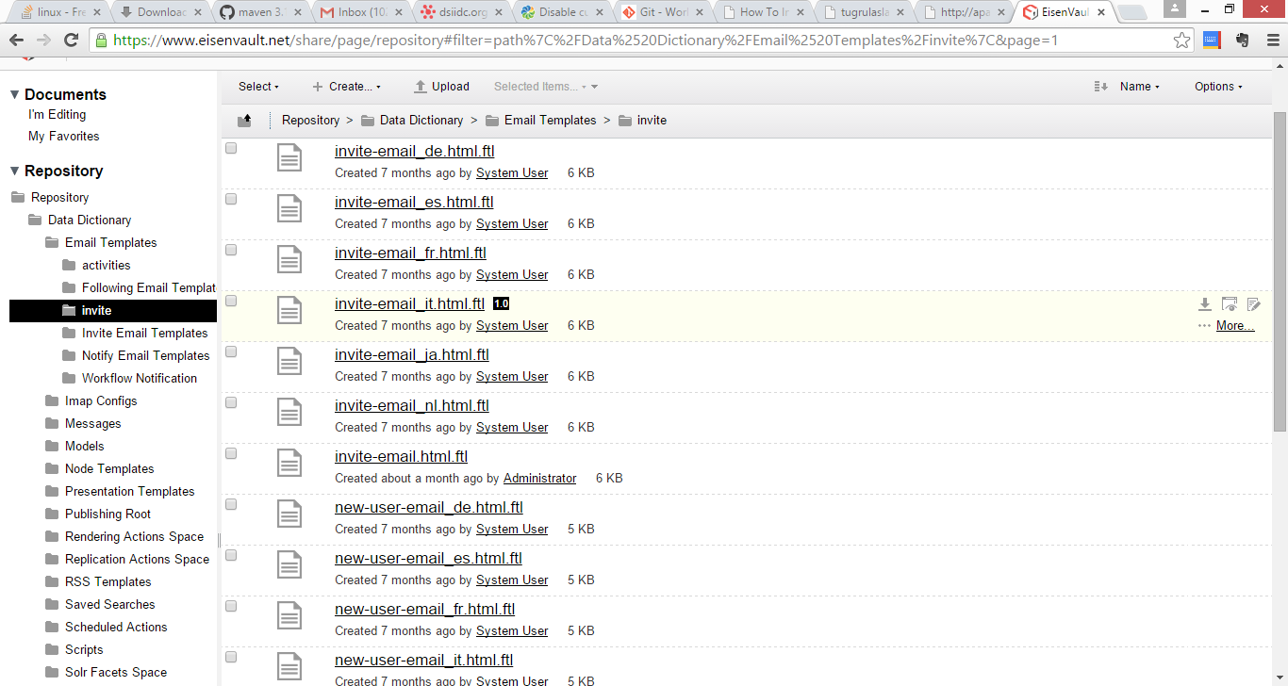

- To edit workflow Tasks invitation. Navigate Repository>Data Dictionary>Email Templates>Workflow Notification and edit the file wf-email.html.ftl and remove img alfresco logo entry from it.
- Repeat steps for all email templates in all directories under Repository>Data Dictionary>Email Templates
- Repeat for all Tenants on the system – login as the admin for that tenant for this purpose

